**India Skills Competition**

**Industrial Design Technology**

**Level-01 Sample Test 01**

**Test project includes the following sections:**

**1. Competition format**

**2. Competition task**

**3. Test project modules and allocated time**

**4. Assessment Criteria**

**Working hours for test completion: 90mins**

**1. COMPETITION FORMAT**

Individual competition.

**2. TASKS**

Object of the test is to identify the suitable candidate for skill test. The test will assess the candidate’s design aptitude and knowledge, technical knowledge. The test will be proctored online exam and the candidate can attend the test for their home or office.

**Materials and equipment:**

Candidate need to get a dedicated PC or a Laptop with uninterrupted internet connection, good quality webcam, microphone and smartphone. Candidate need to get stationary items such as A4 sheets, pencils, pen, ruler, eraser, etc.

**3. Test modules and allocated time**

The test contains questions in following 3 parts.

* 1. Part-A: Contain 50 Multiple choice questions of one mark each. Time allocated is 50 Minutes.
  2. Part-B: Contains a descriptive question of 25 marks. The candidate need to write the answer in 120 words. Time allocated is 20 Minutes.
  3. Part-C: It is an illustrative question carries 25 marks. The candidate need answer the question using to illustration in a A4 sheet. Time allocated is 20 Minutes.

Refer Appendix 01 for sample questions.

**Appendix 01: Sample test questions.**

**Part-A** (50 questions of 1 Marks each)

Candidate need to select the right answer from the 4 options given in each questions. Each question carries 1 marks.

1. Which year Bauhaus design moment started?

A)1900 B) 1919 C) 1945 D) 1984

2. Which material is used to manufacture the computer mouse body?

A) ABS B) PC C) PP D) PE

3. An incomplete square is given below. Which of the given set(s) of shapes can complete the square?

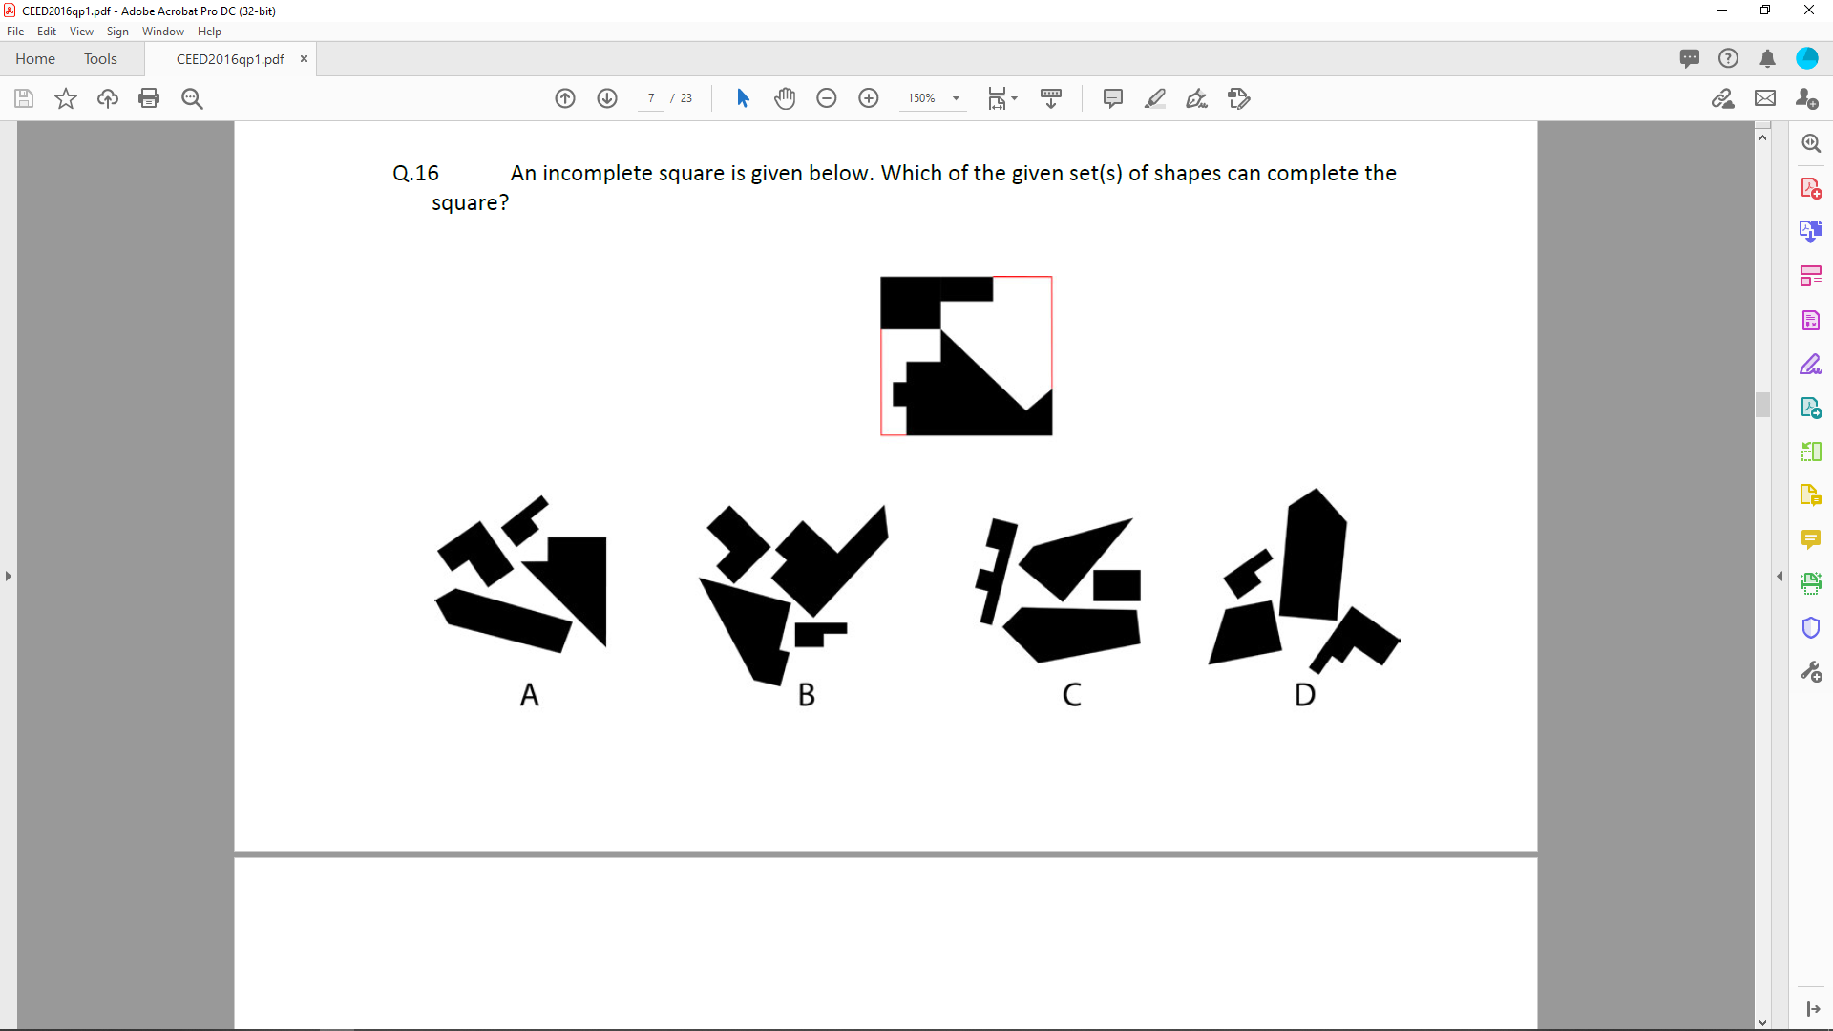

4. What is RULA stands for?

A) Rapid Upper limit assessment

B) Required upper limb adjustment

C) Rapid Upper Limb Assessment

D) Required under limp adjustment

5. Which of the following finishing process does not add thickness to the base component?

A) Chrome plating B) Chemical vapor deposition

C) Anodising D) Powder coating

6. How much distance (in cm) will the bicycle shown below travel, if the pedal makes 1.5 revolutions? (Assume π = 22/7).



A)350 B) 330 C) 150 D) 227

7. Which of the following is a 3D modelling software.

A) Photoshop B) Fusion 360 C) KeyShot D) 3D paint

8. Which of the following is the symbol for 1st angle projection?

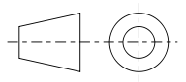 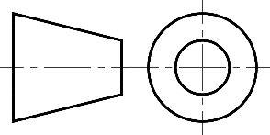

**B**

**A**

 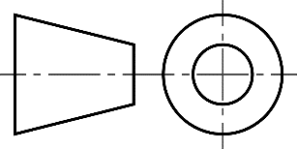

**D**

**C**

9. Identify the brand of the product.

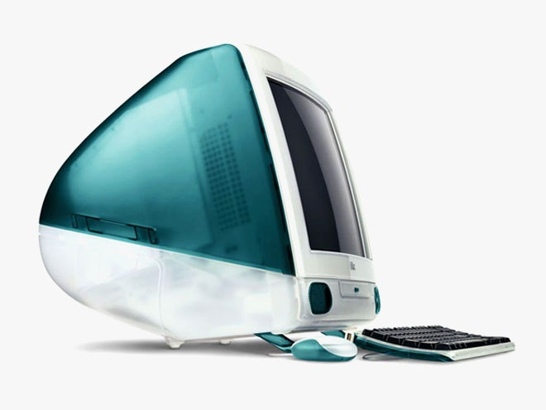

A) Intel B) Apple C) Microsoft D) Wipro

10. Which word does not suitably describe the effect of the image below?



A) Rhythm B) Hypnosis C) Spiral D) Continuation

**Part-B** (One question of 25 Marks)

Select one product that you like from the following list. Being a designer, describe in 120 words why you like the selected product and compare it with other 2.

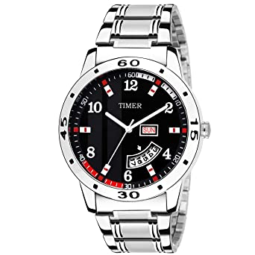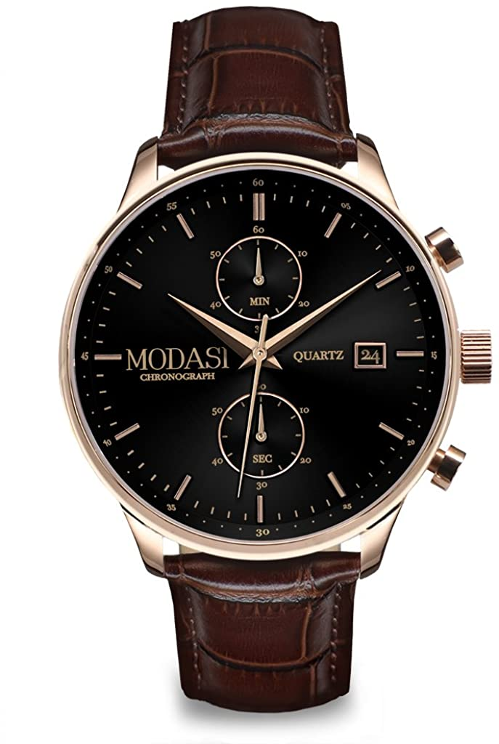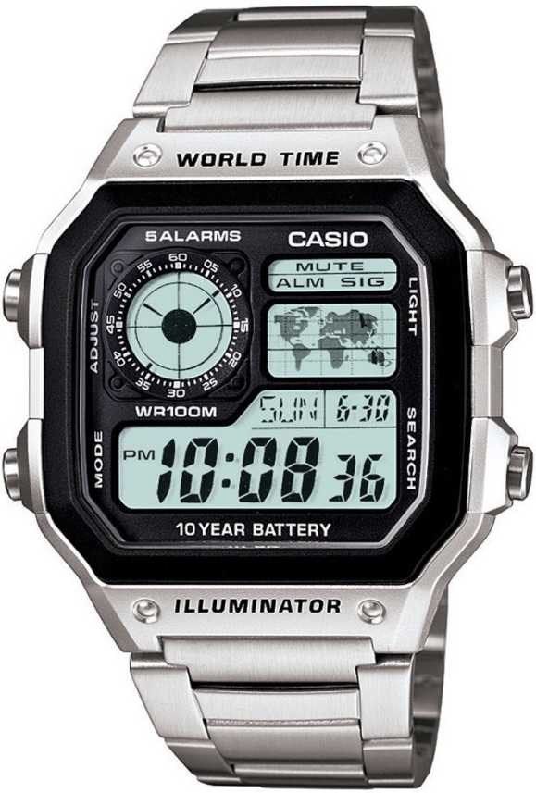

**A**

**B**

**C**

**Part-C** (One question of 25 Marks)

Illustrate the key steps involved in operating a mixer grinder in a kitchen. Complete illustration and description need to be fit into 1 A4 sheet.

The finished sheet need to be scanned and attached in the option provided.